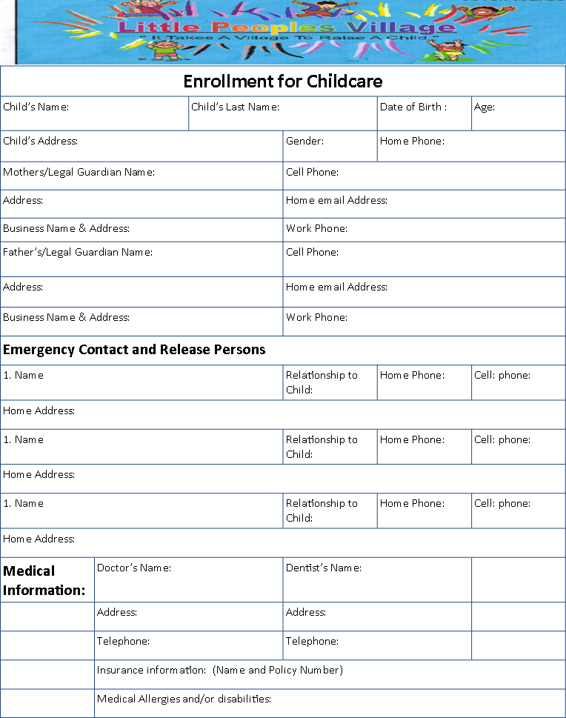
Enrollment for Before & After Care

Grade:

Permission to text: YES or NO Provider -
Home email

Home email
Permission to text: YES or NO Provider -

All families please note that during the school year our school age program serves as before and after care only. We only offer full day and half day care based on the school schedule. You must sign-up for extra care, and payment is due without regard to absence, unless you are taking a vacation week during a regular school week.
You are NOT responsible to pay extra for Winter Recess or Spring Recess unless your child will be in attendance. ELRC families, please keep in mind winter and spring recess absences DO count towards your annual allotment of 40 absences from July 1st-June 30th.

½ Day & Full Day Fees
½ Day , typical before care 11:30/12 or 1/1:30 dismissal $15 additional/day
½ Day , typical aftercare 11:30/12 or 1/1:30 dismissal $10 additional/day
Full Day, typical before care 7:00am -5:30pm $20 additional/day
Full Day, typical aftercare 7:00am -5:30pm $17 additional/day
Full Day, during recess/break 7:00am -5:30pm $35/day or $155/wk
Full Day, Summer 7:00am -5:30pm $40/day or $200/wk

ELRC families: You are responsible to pay the day rates listed above IF your child has more than 40 absences. Additionally, you are responsible to pay any activity fees (which are above what CCIS covers), and the fees are limited to extended holiday care & summer care. Activity fees are typically between $5-$25 per week.
Discovery Zone Learning Center School-Age Rate Agreement and Contract
Child’s Name |  |  | School & Grade | Birth date
Fee Policy (to be completed by staff, reviewed and initialed by the parent/guardian/sponsor after completion)
- Daily Schedule Time ________-________AM to _______-_______PM  Before or After care fee $_______; Both before & after care $_______ |  |  |  | Initial  1._____
- Child’s first day of school will be _______________. Your weekly fee or copay is $ _____________due on_____________. In addition to my ELRC copay, there is a $10 weekly fee from Discovery Zone.  - My ERLC caseworker is_______________ and record #____________.  - One week’s deposit of $ ___________due by _______________. |  |  |  | 2._____  3._____  4._____
- Schedule: ____ school weeks only ____winter recess ____spring recess ____all half days ____all full days off ____as needed holidays |  |  |  | 5._____
- Tuition is due on Friday prior to the week of services or a late fee of $10 will be applied by 6:00PM on Monday. Please note, there is an additional $5 per month if Tuition Express service is not used. |  |  |  | 6._____
- Tuition is not subject to discounts for holidays, emergency closures (i.e., weather), or absence other than hospitalization, contagious illness, or absence at the request of a doctor (a written doctor’s not is required to receive credit). |  |  |  | 7._____
- I agree to pay the full tuition fee even if my child is absent for one or more days. |  |  |  | 8._____
- A non-refundable new student registration fee of $75.00 per child or $100 per family is for the School-age program. |  |  |  | 9._____
- A late pick-up fee of $1 per minute per child is due if my child is not picked up after contract time.  - School Closed days: Drop off past 9:00am is not permitted, account will be locked |  |  |  | 10._____  11._____
- Accounts 10 days past due may result in termination of service. |  |  |  | 12._____
- My child may have opportunity to participate in a special activity or field trip that may have an additional fee due before the day of the event. A specific permission slip may be required. |  |  |  | 13._____
- All returned checks or ACH transactions (automatic debits) will be charged a fee up to the maximum amount allowed by law. Two or more returned checks or ACH transactions will result in my account being placed on a cash or money order status. |  |  |  | 15.____
Primary Parent/Guardian/Sponsor Signature | date | Center Staff Signature |  | Date
Medical Policies
- I agree to provide the center with updated medical and immunization information for my child. This information must be kept current in accordance with state childcare regulations. |  |  |  | 1._____
- I have provided a copy of my child’s medical insurance card to be kept on file in case of emergency. |  |  |  | 2. ____
- I agree to provide information to the center about my child’s conditions, illness, allergies or other needs. |  |  |  | 3._____
- If my child becomes ill with a reportable contagious disease, I understand that he/she will not be able to return until I bring in a physician’s note stating that he/she is no longer contagious. |  |  |  | 4._____
- If my child becomes ill during his/her time at the child care center, the staff will contact me to pick up my child. I will arrange pick up as soon as possible but within 2 hours after being contacted. If I can’t be reached the staff will contact those listed in the Emergency Contact list. |  |  |  | 5._____
- If my child has an IEP, I will disclose this information to Discovery Zone, as well as work with administration to help continue this support for my child |  |  |  | 6._____
Emergency Medical Authorization & Consent
- In case of medical emergency, the staff will attempt to contact me, those listed in the Child Emergency Contact list and lastly my physician. In a life-threatening emergency 911 will be called first. |  |  |  |  | 1._____
- In case of a medical emergency, I agree that my child may receive first aid and / or CPR. |  |  |  |  | 2._____
- In case of a medical emergency, I permit the transportation of my child to a local hospital or other urgent care facility, if necessary, by paramedics or other. |  |  |  |  | 3._____
- In case of a medical emergency I will be responsible for the emergency medical expenses. |  |  |  |  | 4._____
- In case of an accidental ingestion of a poisonous substance, I consent to my child being treated as directed by the Poison Control Center. |  |  |  |  | 5._____
- I give permission for this center to apply  sunscreen  insect repellant. Check the products you permit. |  |  |  |  | 6._____
- I understand that I must provide my own sunscreen and insect repellant with a valid expiration date, and it will be labeled with my child’s name. Please list any special instructions.  ________________________________________________________ |  |  |  |  | 7._____

Private Employment Acknowledgement and Release
Any arrangement / employment between me and staff of this center (i.e.babysitting), outside of the programs and services offered by this center, is an individual endeavor and private matter not connected or sanctioned by this center. This center shall remain harmless from any such arrangement. | 1._____
Services to be provided
Discovery Zone Learning center will provide each child with a Christ centered curriculum, alongside of developmentally appropriate curriculum. | 1._____
Discovery Zone Learning Center will provide all meals and snack in accordance with the Child and Adult Food Care Program (CACFP). | 2._____
Twice a year your child’s teacher will complete a service report based on intentional observations of the child’s skill level. Parent teacher conferences are held at that time to review the service reports and speak with the teacher about your child’s progress. | 3._____
Handbook Acknowledgement
- I understand and agree that it is my responsibility to read and familiarize myself with policies and procedures outlined in the Family Handbook and agree to abide by them. | 1._____
- I understand that it is my responsibility to go directly to management with any questions I may have regarding the policies and procedures and information contained in this enrollment Agreement. | 2._____
- Information contained in the Family Handbook may be subject to change. | 3._____

NOTE: A receipt for income tax purposes will be provided any time one is requested.

Contract Approval
I certify that I have read, understand, and accept all of the terms and conditions described in this Enrollment Agreement and the School Age Family Handbook. | 1._____

Primary Parent/Guardian/Sponsor Signature | Date | Center Staff Signature | Date

